**Lab 5**

**TASK 1:**

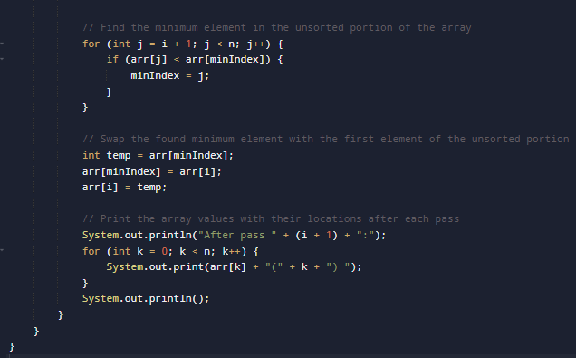

**Output:**

**Task 2:**

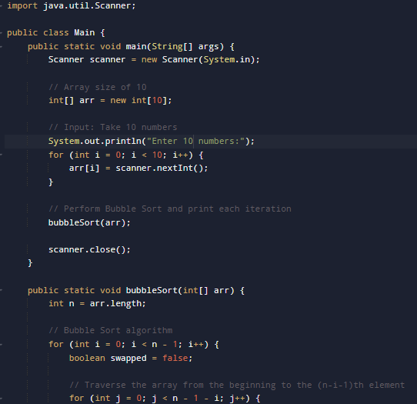

**Output:**

**Task 3:**

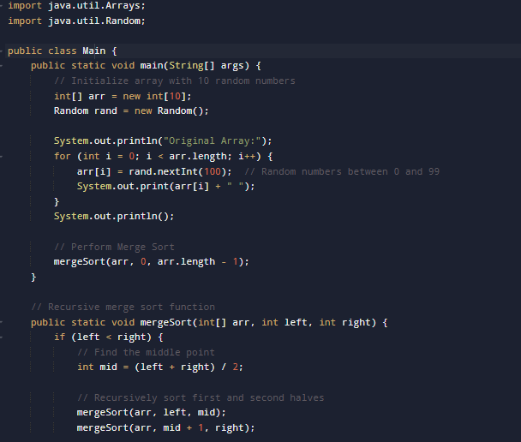

**Output:**

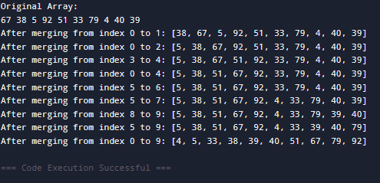

**HomeTasks:**

**TASK:**

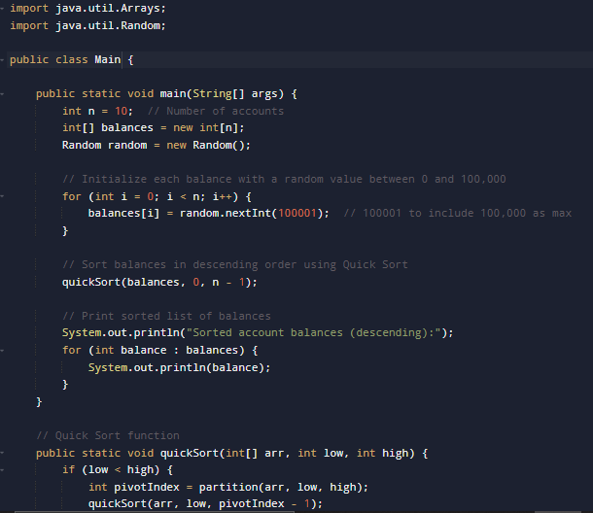

**Output:**

**TASK:**

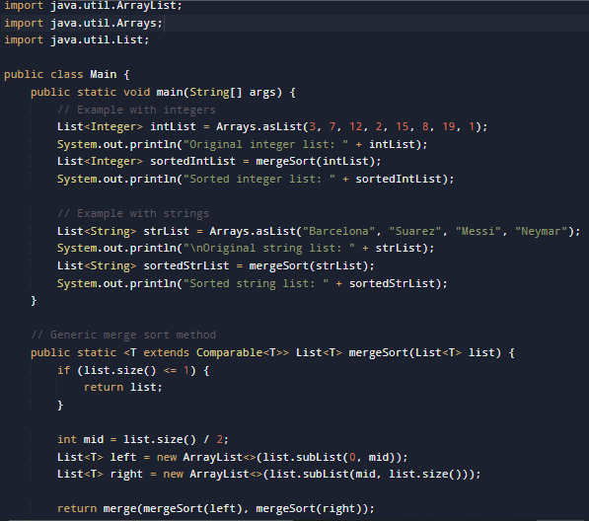

**Output:**

